- Internship Name : Data Analysis
- Task Name: Task 8 : Importing And Exporting Datasets using Pandas
- Your Name : Shubhangi Naresh Khonde
- Internship Organization :
- Date:

1. Introduction
In data analysis, data is usually stored in files such as CSV and Excel sheets. Pandas provides simple functions to read data from these files into a DataFrame and to save the results back into files. In this task, I practiced the four main Pandas input/output functions: read_csv(), read_excel(), to_csv() and to_excel(), using a real employee dataset.

2. Objectives
- To import a CSV file into a Pandas DataFrame using read_csv()
- To export a DataFrame to an Excel file using to_excel()
- To import an Excel file into a DataFrame using read_excel()
- To export filtered data to a CSV file using to_csv()
- To verify that the exported files are created and readable

3. Tools and Technologies Used
- Language: Python 3.13
- Libraries: Pandas, openpyxl (for reading/writing Excel files), os
- Environment: Jupyter Notebook in Visual Studio Code
- Dataset: Excel_Internship_Task.csv (employee records)

4. Dataset Description
The dataset contains 2500 employee records (rows) and 14 columns:
Column | Description
Employee_ID | Unique ID of the employee
Employee_Name | Name of the employee
Gender | Male / Female
Age | Age of the employee
Department | Department such as Sales, IT, HR, Finance, Marketing
Job_Title | Designation of the employee
City | City of work
State | State of work
Joining_Date | Date of joining
Salary | Salary of the employee
Performance_Score | Performance score
Bonus | Bonus amount
Employment_Status | Active / Inactive / On Leave
Grade | Grade of the employee

5. Methodology and Implementation

Step 1: Importing Libraries
Pandas was imported as pd. The openpyxl library was installed because Pandas uses it internally to read and write .xlsx files.
!pip install openpyxl
import pandas as pd

Step 2: Importing a CSV File using read_csv()
The employee dataset was loaded from a CSV file into a DataFrame, and head() was used to preview the first 5 rows.
df = pd.read_csv(r"C:\Users\khond\OneDrive\Desktop\Python Internship Task\Excel_Internship_Task.csv")
df.head()

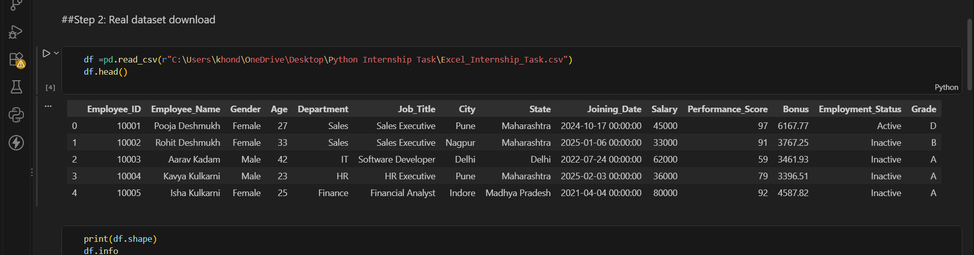

Step 3: Understanding the Dataset
The shape of the DataFrame and its structure were checked. The shape was (2500, 14), meaning 2500 rows and 14 columns. The info() function shows the column names, non-null counts and data types.
Print(df.shape)
df.info()
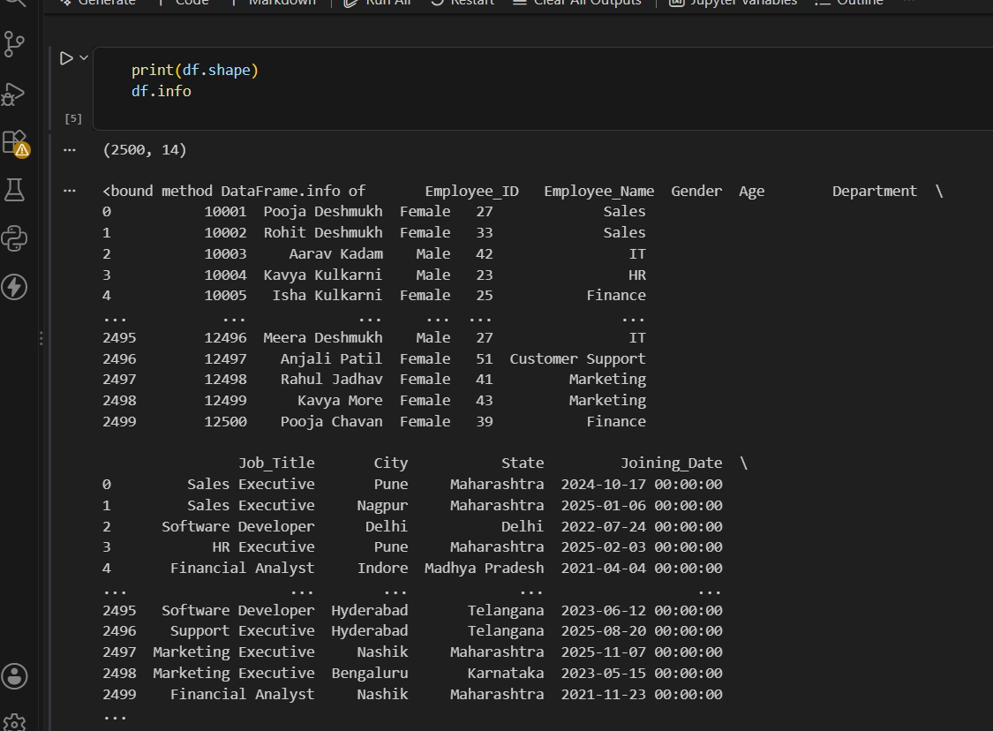

Step 4: Exporting to Excel using to_excel()
The complete DataFrame was saved as an Excel file. The parameter index=False prevents the row index from being saved as an extra column.
df.to_excel("Employee_Output.xlsx", index=False)

5: Importing an Excel File using read_excel()
The exported Excel file was read back into a new DataFrame to confirm that the data was saved correctly.
Df_excel = pd.read_excel(“Employee_Output.xlsx”)
df_excel.head()
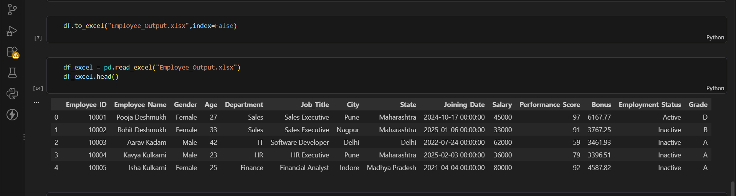

Step 6: Exporting Filtered Data to CSV using to_csv()
Instead of saving all data, only the employees whose Employment_Status is Active were filtered and exported to a new CSV file. The file was then read back to verify it.
active_emp = df[df["Employment_Status"] == "Active"]
active_emp.to_csv("Active_Employees.csv", index=False)
pd.read_csv("Active_Employees.csv").head()

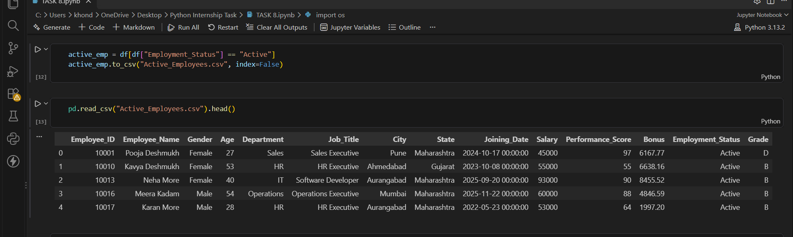

Step 7: Verifying the Created Files
The os module was used to list the files in the working folder. The output showed that Employee_Output.xlsx and Active_Employees.csv were created successfully.
import os
print(os.listdir())

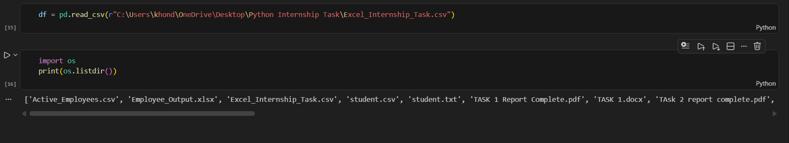
6. Summary of Functions Used
Function | Purpose | File Used
read_csv() | Import data from a CSV file | Excel_Internship_Task.csv
to_excel() | Export a DataFrame to an Excel file | Employee_Output.xlsx
read_excel() | Import data from an Excel file | Employee_Output.xlsx
to_csv() | Export a DataFrame to a CSV file | Active_Employees.csv

7. Observations
- The dataset has 2500 rows and 14 columns, so it is a good example of a real-world dataset.
- Data exported with to_excel() and to_csv() was read back with the same values, so no data was lost.
- Filtering a DataFrame before exporting allows only the required records to be saved.
- Using index=False keeps the exported files clean, without an extra index column.

8. Learning Outcomes
- I learned how to import CSV and Excel files into Pandas DataFrames.
- I learned how to export DataFrames to Excel and CSV files.
- I understood the importance of using the correct function for each file type.
- I learned how to give file paths in Python and how to check files using the os module.
- I learned how to read common errors and fix them.

9. Conclusion
This task gave me practical experience in working with real datasets in Pandas. I successfully imported a CSV file, exported data to Excel, imported the Excel file, and exported filtered data to CSV. These input/output skills are essential for any data analysis workflow, because data is usually received and shared in these file formats.

